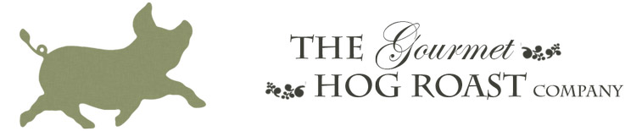

Gourmet Hog Roast POLICY STATEMENT IN COMPLIANCE WITH
THE NEW GENERAL DATA PROTECTION REGULATION (GDPR)

In May 2018 the laws around data protection are changing, affecting the rules on data capture, storage and processing. As customers of the GHR Catering trading as Gourmet Hog Roast and With Fire, we hold and use your data in the form of your name and email address. The GHR Ltd acts as the data controller in this regard.
How we will use your information when you give your data to Gourmet Hog Roast and With Fire ,or you sign up as a new recipient of our newsletter.
This statement explains why we ask for your personal information, how we store and use it and who we may share it with, and what your rights are.
Why we ask for your personal information.
We hold your name and email address for the simple and sole purpose of distributing our monthly newsletter and other periodic updates on new menu options, Taster Days, and special events. By consenting to us holding your information we can ensure you are kept informed with news from the Gourmet Hog Roast and With Fire. If you would like us to continue to hold your name and email address please complete the short online consent form linked from the April 2018 newsletter.
Who is your data shared with.
Your date will only be shared within the Gourmet Hog Roast and With Fire franchise network. We will never sell or otherwise share your data to other third parties or use it for anything other than keeping you up-to-date with Gourmet Hog Roast and With Fire news and events.
How we store your information.
The personal information you consent to give us is stored on a database on Gourmet Hog Roast and With Fire server which can only be accessed by the Gourmet Hog Roast and With Fire office staff. The server is a highly secure system and is fully compliant with GDPR. This server itself is backed up to Dropbox.
Your rights.
You have the right to see the information that we hold on you at any time, by submitting a Subject Access Request (SAR) in writing by contacting the Gourmet Hog Roast and With Fire as shown below. You may also request to opt out of any of these services or have your details deleted from the database at any time, either by contacting the Gourmet Hog Roast and With Fire and letting us know what your preferences are, or by clinking the unsubscribe link on each newsletter we send.
GHR Catering Ltd
Unit 22 & 16
London
SW19 8UG

Or email:
info@gourmet-hog-roast.co.uk or info@withfire.co.uk
When we receive your information, we only use it for the purposes that you have agreed to in your consent form and we will adhere to all aspects of the new General Data Protection Regulation (GDPR) that will be introduced in May 2018.

